Compressor Performance Management - Literature Review

# Research Question

What is the best performance management method for air compressors?

# Method

To complete this review the following search engines were used:

1. Google Scholar
2. Science Direct
3. Engineering Village
4. IEEE

Search terms used were in the form of “compressed air”, “air compressor” and “pneumatic system” together with the particular approach or method being reviewed, e.g. “air compressor fault detection neural networks”.

# Background

In 2012 industry consumed 2,542 Mtoe of energy globally, which represented over 28% of the 8,980 Mtoe of global final energy consumption (IEA 2012). In an Irish context, industry consumed 2.26 Mtoe of energy in 2012, representing almost 22% of Ireland’s 10.3 Mtoe of final energy consumption. Within the category of industrial energy, compressed air is recognised as an energy intensive utility, accounting for 10% of industrial electricity in the European Union (Saidur et al. 2010). Energy costs typically account for 78% of the total life cycle cost of a compressed air system (Radgen 2006). Compressed air is known colloquially in industry as the “fourth fuel”, due to the high electrical cost associated with generation. Compressed air systems are typically running at 19% overall system efficiency (Saidur et al. 2010), due to energy losses largely due to lost heat of generation and leakages.

Compressed air is generated in industry using a wide variety of equipment types and configurations. Different types of equipment are suited to different applications in terms of volumetric and pressure requirements. The three key types of compressor installed in industry today are reciprocating, rotary, and centrifugal machines. Their suitability to different volumetric and pressure requirements is summarised in **Figure 1** (SEAI 2007).

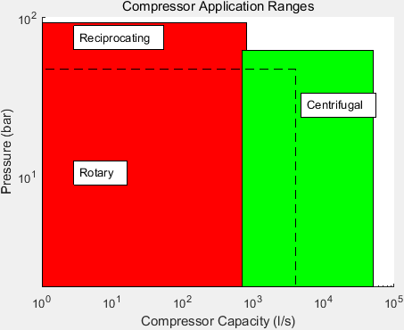

Figure : Typical Compressor Application Ranges

Reciprocating and rotary machines are both positive displacement type machines. They work through isolation of a quantity of air in a space which is then reduced in volume. Centrifugal machines are aerodynamic machines, which operate by imparting kinetic energy to air, which is then converted to pressure energy by stopping the moving air.

Given that compressed air represents such a dense form of energy transport, it is beneficial in terms of long and short term overall energy efficiency goals to manage the performance of air compressors. Performance management is typically achieved through means such as those in **Table 1.**

|  |  |  |
| --- | --- | --- |
| ***Performance Management Method*** | ***Advantages*** | ***Disadvantages*** |
| Maintenance Contracts | Security of asset reliability | Potential for unnecessary work |
| Periodic Audits | Likely to pick up on common opportunities for improvement | Dependent on skill level of auditor |
| Sequence Controllers | Can draw on manufacturer knowledge of system operation | Initial configuration may not be maintained due to system changes |
| BMS Monitoring | Desk-based site wide monitoring capability | Dependent on skill level of BMS reviewer. Unable to pick up on sensor errors |

Table : Compressed Air System Performance Management Methods

As is outlined in **Table 1**, the key disadvantages of existing methods are either that they are manual and periodic in nature, or require the intervention of a human expert in compressed air systems to be effective. In the case of maintenance contracts and periodic audits, there is also the potential for unnecessary work to be carried out, as both these measures are typically carried out on a timescale basis. The intervention of a human expert also lends itself to an inefficient method of performance measurement. An expert may be particularly well versed with one type of system, but not another. The disparate range of compressed air systems can lead to an expert restricting themselves to one type of system, preventing possible lessons learned to be applied in other suitable cases.

Research is being carried out to define the future of compressed air system performance management. In this review the research considered is that of ongoing analysis of compressed air system data. This ongoing analysis could be designated as having any of the goals outlined in **Table 2**.

The high level goals or approaches given in **Table 2** may be achieved using a variety of methods, which are discussed in **Section 4.**

|  |  |  |
| --- | --- | --- |
| ***Goal*** | ***Description*** | ***Example Work*** |
| Fault Detection and Diagnosis | Monitor system parameters to determine when system is in fault condition and the potential reasons for the identified fault | Using vibration, pressure and current signals to diagnose valve faults for a reciprocating compressor (Tran et al. 2014) |
| Prognostics | Monitoring system parameters to determine when a component of a system will no longer perform its intended function (Vachtsevanos et al. 2006) | Determining the remaining useful life of a gaseous circuit breaker based on gas pressure and ambient temperature (Catterson & Costello 2013) |
| Analytics | Monitoring system parameters to discover meaningful patterns which may advise on potential improvements to system operation | Determining abnormal appliance power consumption based on analysis of individual appliance’s acoustic noise (Pathak et al. 2015) |
| Automated Commissioning | Achieving, verifying and documenting that the performance of a system satisfies the current user requirement | Automatically carrying out the normal testing procedure for an air compressor by replicating the tasks normally carried out during commissioning (Mazid & Martin 2008) |
| Optimisation | Improving system operation or design as measured against some defined criteria | Development of a tool which delivers an optimal design for a compressed air system based on energy and life cycle costing (Friden et al. 2012) |
| Control | Managing the operation of a system in order that operating conditions remain in line with design states and undesirable states are avoided | Development of a control algorithm for fixed speed compressors that provides the pressure control capabilities of a variable speed system while limiting energy consumption (Facchinetti et al. n.d.) |

Table : Analysis Approaches for Industrial Equipment

# Current Methods

This review categorises industrial utility performance management methods into three high-level classifications, which are themselves subdivided into individual methods. These three categories are:

1. Quantitative Model Based
2. Qualitative Model Based
3. Data Based

These three categories are shown visually in **Figure 2**, which is adapted from previous works on system performance management and diagnostic approaches (Katipamula & Brambley 2005; Venkatasubramanian, Rengaswamy, Yin, et al. 2003; Venkatasubramanian, Rengaswamy & Kavuri 2003; Venkatasubramanian 2003; Gao et al. 2015a; Gao et al. 2015b).

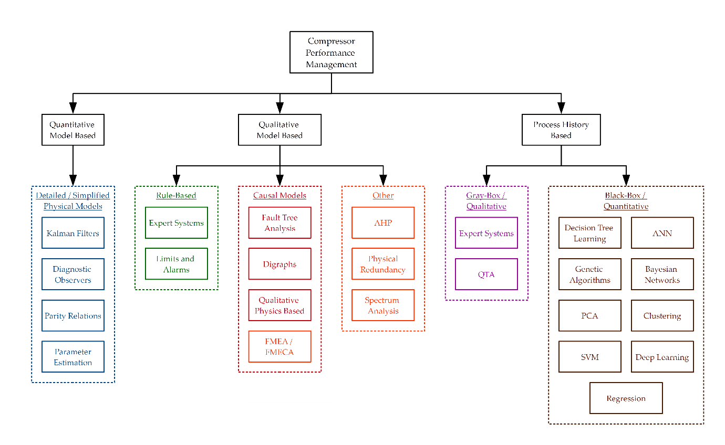

Figure : Performance Management Methods

These three categories of method have different capabilities, benefits and disadvantages, as shown in **Table 3, Table 4,** and **Table 5.**

|  |  |  |  |  |
| --- | --- | --- | --- | --- |
| ***Method*** | ***Description*** | ***Benefits*** | ***Disadvantages*** | ***Examples*** |
| Kalman Filters | A Kalman filter allows the combination of observed and predicted parameters to more accurately predict future parameters than with a physical model alone. It also allows for the reduction of the effects of noisy data on models. | Very accurate  Transients may be modelled | Computationally expensive  Complex to create  Typically require many inputs from system | Surge control for axial compressors (Backi et al. 2013)  Fault detection for gas turbine compressors (Salar et al. 2010)  State estimation of a thermal power plant (Nair et al. 2011)  Leakage detection of a pneumatic network (Krichel & Sawodny 2011) |
| Diagnostic Observers | Employing state observers, typically one for each fault, which represent a different output from a model, in order that observed differences in outputs may be attributed to faults to how to change a model to remove deviations from expected behaviour | Accurate isolation of individual faults possible | Observers required for each individual potential fault state | Fault detection of a steam boiler feed water preheater (Tarantino et al. 2000)  Estimation of a steam boiler’s pressure given fuel and feed water conditions (Ramezanifar et al. 2006)  Surge control for axial compressors (Backi et al. 2013) |
| Parity Relations | Rearranging and transforming input-output models of a system in order to highlight individual fault conditions | Accurate isolation of individual faults possible | Less effective at identifying multiplicative faults | Fault diagnosis of a wind farm using interval nonlinear parameter-varying parity equations (Blesa et al. 2014) |
| Parameter Estimation | Comparison of modelled data, normally using ordinary and partial differential equations, with measured data, with analysis of any residuals to diagnose faults | High level of confidence in modelled data | Detailed physical model required for accuracy  Difficult to isolate individual causes of faults  Computationally expensive | Optimisation of the modelling of a multistage compressor using parameter estimation to determine the surge line (Dapeng Niu et al. 2011) |

Table : Quantitative Model Based Methods

|  |  |  |  |  |
| --- | --- | --- | --- | --- |
| ***Method*** | ***Description*** | ***Benefits*** | ***Disadvantages*** | ***Examples*** |
| Expert Systems | Using if-then-else rules derived from engineering knowledge of a system’s operation to flag when and why a fault is present in operation |  |  | Fault diagnosis assistance using IF-THEN rules for an air compressor (Liu 2001) |
| Physical Redundancy | Installing parallel sensors in order that site personnel be notified of an error if sensor values do not match |  |  | Development of a framework for analysis of fault detection schemes based on analytical and physically redundant sensor for aircraft (Wheeler et al. 2011) |
| Analytical Hierarchy Process | Decision support for selection of a particular approach, e.g. for maintenance strategy, over another based on pairwise comparisons of suitability toward various goals |  |  | Maintenance strategy selection for equipment at an oil refinery (Bevilacqua & Braglia 2000) |
| Spectrum Analysis | Analysis of compressor drive and vibrational frequency response to alert when response drifts from normal |  |  | Vibration analysis of reciprocating comrpessors for valve failure diagnosis (Ruilin Lin et al. 2010) |
| Fault Tree Analysis | Postulation of potential areas of failure in equipment |  |  | Reliability assessment of an anti-surge control system for a centrifugal compressor (Ren et al. 2012) |
| FMEA / FMECA | Analysis of site equipment to determine potential areas of failure and potential effect on other equipment |  |  | Development of a compressor safety evaluation model (Zhu et al. 2013) |
| Qualitative Physics Based | Derivation of qualitative equations from fundamental physical equations governing system operation to allow for analysis without explicit requirement for numerical values |  |  | Fault Detection for an AHU (Glass et al. 1995) |
| Digraphs | Representation of qualitative models using directed graphs to efficiently incorporate system behaviour for effective analysis |  |  | FDD for a typical industrial process using SDG for model decomposition (Shin et al. 2007) |
| Limits and Alarms | Implementation of user defined limits on key parameters which flag when exceeded or are not met | With correct identification of thresholds can quickly highlight issues with systems | Little diagnosis and isolation potential  Correct selection of thresholds dependent on user expertise | Incorporated into modern compressor PLCs |

Table : Qualitative Model Based Methods

| ***Method*** | ***Description*** | ***Benefits*** | ***Disadvantages*** | ***Examples*** |
| --- | --- | --- | --- | --- |
| Support Vector Machine / Relevance Vector Machine | A supervised learning technique which when given a sample data set which is labelled according to which class each point belongs in, can determine the optimal plane which splits classes allowing accurate future classification of variables |  |  | Compressed air load forecasting for large flows (Liu et al. 2013)  Fault diagnosis for reciprocating air compressor valves (Wang et al. 2010; Cui et al. 2009; Qin et al. 2012; James Li & Yu 1995)  Fault diagnosis for reciprocating air compressors (Verma et al. 2011) |
| PCA | Analysis of a population of variables to determine the population extremes in a given number of directions or components, allowing categorisation of each data point in terms of its position in each direction |  |  | Sensor fault detection, diagnosis and estimation for centrifugal chillers (Wang & Cui 2005)  Fault detection and isolation for a centrifugal compressor (Zanoli & Astolfi 2013)  Sensor and actuator fault diagnosis for a centrifugal compressor (Zanoli et al. 2010a) |
| Artificial Neural Networks | Creation of a network of elements or neurons which may determine output values based on interconnected element's response to external inputs. Networks may be supervised where instances of faulty operation are labelled, allowing the network to generate expected outputs for arbitrary unknown inputs. Networks may also be unsupervised, in which case the topology is adaptively determined based on the inputs. |  |  | Valve failure detection for reciprocating compressors (Namdeo et al. 2008)  Neural network based fault diagnosis of a reciprocating compressor employing genetic algorithms for initial parameter identification (Jinru et al. 2008)  Performance prediction of a centrifugal air compressor employing artificial neural networks and genetic algorithms (Luo Fangqiong & Huang Shengzhong 2011)  Generation of a gas generator’s compressor performance characteristic map (Ghorbanian & Gholamrezaei 2009; Yu et al. 2007) |
| Genetic Algorithms | Determining the optimum point a system can operate at, by selecting random members of a population of samples and using them as parents of successive samples, which tend toward the optimal sample |  |  | Noise minimisation of a hermetic compressor (Dasilva 2004)  Neural network based fault diagnosis of a reciprocating compressor employing genetic algorithms for initial parameter identification (Jinru et al. 2008)  Performance prediction of a centrifugal air compressor employing artificial neural networks and genetic algorithms (Luo Fangqiong & Huang Shengzhong 2011)  Parameter identification for a centrifugal compressor model (Xiaogang et al. 2013) |
| Decision Tree Learning | Automatic classification of output variables by organising data into subsets, generating rules in a tree like structure |  | Highly unstable when perturbations in training data are present | Fault diagnosis for a modular production system (Demetgul 2013) |
| Deep Belief Networks | Stacked Restricted Boltzmann Machines (RBMs), which are themselves simple unsupervised neural networks |  |  | Reciprocating compressor valve fault diagnosis (Tran et al. 2014) |
| Clustering | Grouping data readings into different groups where intragroup similarity is greater than intergroup similarity |  |  | Fault detection and isolation for a centrifugal compressor based on PCA and Clustering (Zanoli et al. 2010b)  Adaptive clustering for pneumatic system fault detection (Petković et al. 2012) |
| Bayesian Networks | Creation by learning or using prior knowledge of graphical probabilistic models which give relationships between variables |  |  | Fault diagnosis of a pneumatic air braking system (Lingling 2010)  Fault detection via classification of compressor variables compressed dimensionally via PCA (Liu & Chen 2009) |
| Regression Modelling | Statistical estimation of the relationship between two or more variables |  |  | Optimisation of a network of compressors in parallel (Kopanos et al. 2015) |

Table : Process History Based Methods

## Quantitative Model Based Methods

In the field of compressor performance management, one approach which may be used is that of the development of a quantitative model describing the compressor’s operation, and analysing actual operation with respect to this modelled operation in order to achieve one of the goals outlined in **Table 2.** This comparison may lead to the generation of differences between measured and modelled variables, which are termed residuals. This concept of inconsistency between variables is known as redundancy.

Redundancy may be either physical or analytical. Physical redundancy relies on the installation of parallel sensors on the system being analysed. Residual differences between parallel sensors may then highlight sensor issues. This form of redundancy has historically been prevalent in safety-critical systems such as aircraft control. However in many applications space and cost requirements render this method less desirable.

Analytical or artificial redundancy may be achieved through formalisation of the fundamental relationships between the states, inputs and outputs of a system, as is the case in quantitative model based methods of performance improvement. This inherent redundancy may take either a direct or a temporal approach.

A direct approach to analytical redundancy is to derive algebraic equations between different sensor measurements. This concept is useful when limited sensor instrumentation is present on a system, as data which may be desirable to know may be calculated from data which is available. If a sensor is available for the calculated value, the concept of redundancy may be used to generate a residual. If the residual exceeds a given threshold then a sensor fault may be present.

In contrast, temporal redundancy is obtained by analysing the difference relationships between sensor outputs and actuator inputs. If an actuator input is intended to produce a difference between sensors, and this difference is not present, then either a sensor or actuator fault may be present.

In this review, four key methods are discussed with respect to the generation of residuals for redundancy purposes. These are outlined in **Table 3**. The key difference between these methods is how the residuals are generated and classified.

### Kalman Filters

Kalman filters allow for prediction of variables for a modelled system. The predictions tend to be more accurate than with a model alone, as the Kalman filter incorporates a degree of refinement to model estimations by minimising the error between predicted and measured data using past values. This is achieved by updating estimates using a weighted average, giving precedence to estimates which were more accurate at predicting values. This has the additional benefit of reducing the effects of noise when comparing predictions with measurements. The residuals generated by comparing predictions and measurements may be used for identification of when a system is in fault condition.

If an arbitrary linear system with finite dimensions is considered, it may be represented by a state-space model as:

Where:

* x(t) is an n-dimensional vector
* A, B and C are matrices with suitable dimensions
* x0 has a mean of and covariance Σ0
* ω(t) and v(t) are Gaussian white noise sequences with means of 0 and the covariance matrix:
  + Where δt-τ is Kronecker’s delta

A Kalman filter operates by minimising the error between predicted and measured values. This is formulated by minimising the cost function:

Where e(t) is the estimation error and is defined by:

A filtered estimate, , will satisfy:

The Kalman filter gain K(t) will then be given by:

Where Σ(t) is an *n* x *n* state error covariance matrix.

By using the above formulation for an improved estimate of a system output, a more accurate prediction may be made than by using the initially developed model. This allows for increased confidence in analysing residuals of significant magnitude for fault detection.

### Diagnostic Observers

The method of diagnostic observers to generate residuals employs the use of individual observers for each potential fault. These observers are designed to be sensitive to the fault in question, while being insensitive to other faults and any unknown inputs. In normal operation, residuals of all observers are small. In the case of a fault occurring, the specific observer which is sensitive to that fault will generate a large residual. This allows for isolation of the relevant fault.

A system may be described by the following discrete time state-space equations:

Where:

* d(t) represents unknown inputs to the system
* p(t) represents actuator faults, plant faults, disturbances and input sensor faults

Observers are designed to take the form:

The construction of an observer is achieved by creating appropriate matrices T, H, J and G.

If denotes the state estimation error of the observer, and the residual generated by the observer, these may be given as:

This may be manipulated to give:

If T is chosen such that , and J chosen such that , then the observer will track the system without being affected by the unknown input . This gives:

*G* is then chosen such that , with *H* stable and . This gives:

In a fault-free condition, and:

For these equations, in a fault free condition the estimation error and residual will follow the system without being affected by the unknown inputs *d(t)*, and the observer is named an unknown input observer.

When the system encounters a sensor fault, the output, estimation error and residual will become:

The estimation error and residual will therefore carry the signature of any sensor faults, while any actuator faults will manifest themselves in the signature of .

In this manner, observers may be designed that are impervious to unknown inputs, and will generate unique signatures in the form of large residuals for system faults.

### Parity Relations

The method of parity relations uses a novel method of checking consistency between modelled and measured variables to determine individual residual signatures for isolated faults. The concept involves rearranging and transforming the system model in order that individual sensor residuals are highlighted and categorised. They are powerful at isolating individual faults, but can be weak when multiplicative faults are observed (Venkatasubramanian, Rengaswamy, Yin, et al. 2003).

If a system is described by the following equation:

Then an instance of a measurement fault can be represented as:

If a projection matrix *V* is chosen such that:

Then a parity vector *p* may be created as:

For a system operating in a fault free condition, *p* = 0. If a single sensor fault is present, then:

In this way, using *V* in combination with *y(t)* allows for the distinction of individual fault signatures associated with deviations from modelled variables. It is clear however that this method is less effective when multiplicative measurement deviations are present.

### Parameter Estimation

Parameter estimation is possibly the most basic method of the quantitative model-based methods for redundancy reviewed in terms of comprehensibility. It is however often the hardest to implement in practice.

Parameter estimation is based on having an accurate parametric model of the relevant system. This model may be derived from input-output data, first principles, or be a reduced order model. In all cases, a process model is required in the form of:

Where *θ* represents the model parameters. These parameters are estimated using values of *y(t)* and *u(t)*, and are related to physical parameters of the system by , where *ϕ* represents the physical parameters of the system. Changes in the physical parameters of the system may be analysed using pattern recognition to diagnose faults. This method is less prescriptive than the other quantitative methods reviewed, and requires a deep fundamental understanding of the system to be analysed in order to be of use when detecting faults.

### Case Study - Kalman Filter Based State Estimation of a Thermal Power Plant

(Nair et al. 2011) presented a paper which described work carried out toward state estimation of a thermal power plant using Kalman Filters. Linear Kalman Filters (LKFs) and Extended Kalman Filters (EKFs) were both employed, and the results compared and contrasted.

For the thermal power plant reviewed in this work, the critical parameter for effective operation of the power plant was the final steam temperature. Thermal power plants typically generate superheated steam, as any degree of wetness in steam delivered to the generator turbine has a detrimental impact on equipment longevity. Final steam temperature may be regulated using a variety of methods including burner tilt angle and burner firing rate. For the boiler reviewed in this work the final steam temperature was regulated using fuel and air flow to the burner.

State estimation is useful from an operational perspective of a power plant as it allows for optimisation of operation, and can be used for predictive control. The authors therefore desired to estimate the state of the power plant, particularly with regard to the conditions of the furnace gas. The operating condition of the furnace gas could then be used for analysis with respect to the final steam temperature.

The state variables used for the Kalman filter were the density and specific enthalpy of the furnace gas. Since these variables are difficult to measure directly, the measured variables used as output variables for the Kalman filter were the pressure and temperature of the furnace gas. The input measured variables were the flow rate of fuel and air.

By creating state-space equations in the manner given in **Section 4.1.1**, a Kalman filter was created to predict the values of the state variables. It was found that since the linear model originally derived for the power plant did not hold true for varying input conditions, the LKF approach gave less than desirable results for accuracy in predicting state variables.

The EKF approach involved invoking a linearization procedure for the Kalman filter in the form of a Taylor approximation. This has the effect of linearising the non-linear functions governing the model around the current measured variables. This approach was found to show improved accuracy in predicting the values of state variables, with a 20% increase in computational time required.

This paper demonstrates the capability of Kalman filters in estimating the values of given state variables for a given process. It shows the need to be mindful of potential deviations in actual process behaviour from any modelled equations. If allowances are made for potential deviations by modifying models to suit the approach of the Kalman filter, satisfactory results may be achieved for state estimation.

## Qualitative Model Based Methods

Qualitative model based methods may be distinguished from quantitative model based methods by their abstraction of the physical principles governing the operation of a system. Where quantitative methods seek precise numerical values for the parameters of a system, qualitative methods are generally satisfied with simplified models of a system.

To demonstrate this difference the example of an air compressor in operation is considered. If a quantitative model is used for analysis of this system, it can require inputs of all possible system and environmental variables (voltage, current, ambient air conditions) in order to make a calculation on what the compressed air flowrate should be. A qualitative approach to this situation would be to hypothesise that with an increase in current drawn by the compressor, an increase in compressed air flowrate should also be observed. While the quantitative approach may flag a slight decrease in performance of the machine if the expected flowrate is not met, the qualitative approach will immediately highlight a serious issue with the compressor if an increase in power does not correspond to an increase in flowrate. The time required to develop quantitative solutions is typically greater than that for qualitative solutions. This suggests that for rapid deployment of ad-hoc compressor performance management solutions, a qualitative approach may be more suitable.

This review focuses on five example qualitative approaches which have potential for use in compressor performance management applications. These example approaches are drawn from **Table 4**.

### Digraphs

Digraphs offer an efficient means of representing qualitative information about a particular system. An example drawn from a previous review paper on fault diagnosis methods (Venkatasubramanian, Rengaswamy & Kavuri 2003) describes a tank containing fluid with an inlet pipe and an outlet pipe. This tank is illustrated in **Figure 3.**

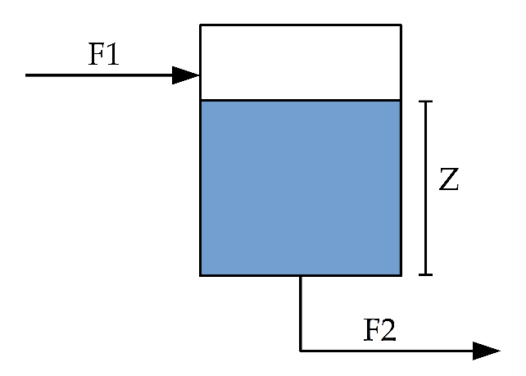

Figure : Tank Example Diagram

The inlet and outlet flowrates are given by F1 and F2 respectively. The depth of fluid in the tank is denoted by Z.

The equations which define this system are:

Where R is a constant associated with the system.

Without knowing numerical values associated with the system, it is possible to construct a directed graph to efficiently represent the above equations. The corresponding digraph is shown in **Figure 4.**

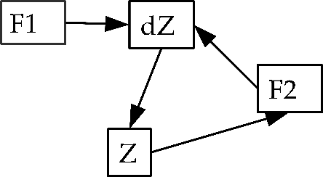

Figure : Tank Example Digraph

The digraph describes the behaviour of the system as follows:

1. An external input causes F1 to change
2. This affects the rate of change of Z, which in turn affects Z
3. The change in Z affects F2, which affects dZ, forming a feedback loop

In a digraph for fault diagnosis, the arrows between nodes are termed arcs. Three types of nodes are typically employed for fault diagnosis:

1. Nodes with only output arcs – these represent independent variables which may change externally to the system. These are typically sued for fault variables.
2. Nodes with input and output arcs – used for process variables.
3. Nodes with input arcs only – used for output variables as they do not affect other variables.

### Rule-Based Expert Systems

An expert system is a computer program which attempts to replicate the reasoning of a human expert in a particular domain. When applied to the field of industrial system fault detection, a common manifestation of an expert system is in the creation of a knowledge base of rules. These rules, which take the form of IF-THEN-ELSE clauses, assess relationships between measured variables, and can diagnose individual faults based on “firing” of pertinent rules.

One widely discussed drawback of this type of knowledge representation is that often the rules are derived heuristically, and may not have a fundamental understanding of the physical processes taking place in a system. If this is the case, then new, previously unseen faults will be difficult to diagnose, and will require expansion of the existing rule set. Without due diligence being paid to correct software structuring techniques, such an expert system can quickly become unwieldy to future modifications.

An example of how a rule-based system can be susceptible to ignorance of potential faults is highlighted in the previous tank example from (Venkatasubramanian, Rengaswamy & Kavuri 2003). An initial rule may be developed that if the valve on the outlet pipe controlling F2 is closed, then Z may not decrease. This is logical as the only way that the depth of fluid in the tank may decrease is if F2 is greater than F1. If Z is observed to decrease then a fault of a failed open outlet valve could reasonably be deduced. However, on inspection of the tank, the wall of the tank may be found to be leaking. The previous deduction of a failed open valve is now found to be incorrect.

A conclusion drawn from this review is that rule-based expert systems offer an excellent means of initially formalising knowledge about a system for the purposes of fault detection. However, in order that a fault detection approach be mindful of potential gaps in the domain knowledge of the human expert creating the rules, a more formal approach is desirable following initial rule based trials.

### Qualitative Physics Based Methods

Qualitative physics based methods attempt to formalise common sense reasoning about physical systems in a way which allows for efficient analysis. Qualitative models are models which do not necessarily require accurate functional relationships between variables or exact numerical values of variables for analysis.

To return to the tank example of **Section 4.2.1**, one way in which a qualitative model may be generated for the system is by the derivation of steady state qualitative equations from the differential equations known for the system. These equations are known as confluence equations, and for the tank example would take the form:

In these equations, the square brackets denote the sign of the variable enclosed within. These equations allow the deduction that if F2 increases, so too must F1 to reach steady state, and likewise for Z and F2. Without knowing anything about the dimensions of the tank or piping, it could be deduced that an increase in F1 will cause an increase in F2, which will be realised through an increase in Z. If any of these qualitative relationships does not hold true when measured it may be concluded that the system is in fault condition.

### Fault Tree Analysis

Fault tree analysis is a method of using computational logic to assess the reasons for faults in a system. A particular fault is identified for a system, and all potential causes for this fault postulated. A complete understanding of the system being assessed is therefore crucial to effective implementation of a fault tree analysis.

By postulating as to what could cause a fault (which is termed a top-level event due to its place in the fault tree), many diagnoses may be arrived at. These diagnoses are intelligently arranged into a tree structure. Decision logic is implemented at junctions between nodes or “leaves” of the tree using traditional logic statements such as AND and OR gates.

An example of an implementation of a fault tree analysis in the compressed air domain is presented in a recent paper (Ren et al. 2012). This paper analyses an anti-surge control system for an air compressor in terms of its reliability. Surge is a phenomenon observed in aerodynamic air compressors when maximum pressure and minimum flow limits are reached. This can manifest itself in the compressed air returning back in the wrong direction through the compressor. This can have devastating effects on the longevity of the machine.

The anti-surge control system assessed in this paper is a recycling system. Sensors detect when the compressor is approaching the surge line, and open a valve to send compressed air back to the inlet of the air compressor. While not necessarily the most energy efficient strategy for compressor control, the effect of recycling the compressed air is to increase the compressed air flowrate through the machine, moving its operating point away from the surge line.

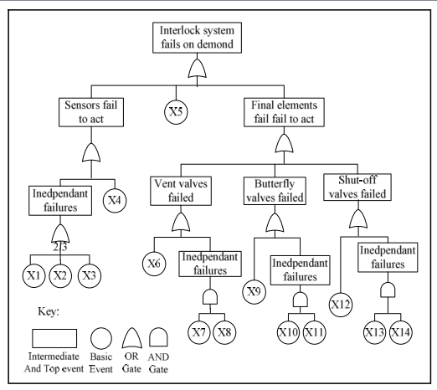

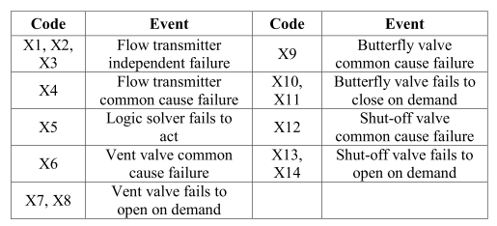

Figure : Example Fault Tree for Anti Surge Control System (Ren et al. 2012)

The fault tree generated by the authors of this work for the anti-surge control system is shown in **Figure 5**. By proposing the possible causes for the interlock or recycling system failing to act, the authors were able to generate the given fault tree allowing for more efficient fault diagnosis than by checking all components individually.

Fault tree analysis is a powerful tool for encoding expert knowledge about a system. However it suffers from a similar drawback as rule-based expert systems. This is that its success in deployment relies largely on the domain expertise of the system owner in creating the fault tree.

### Analytical Hierarchy Process

The Analytical Hierarchy Process (AHP) is a formal method discussed in detail in (Saaty 2008) to support decision making. Areas including maintenance programming of industrial equipment lend themselves to an AHP approach for decision making, as the approach assists with ensuring all possible factors influencing any decision made are considered.

The AHP method involves initially creating a hierarchy scheme for the decision to be made. An example hierarchy scheme is given in **Figure 6.**

Figure : Example AHP Hierarchy Scheme

The hierarchy scheme has three or more levels. The topmost level is the goal, or the question which must be answered. The intermediate level (which may include sublevels) gives the factors which will influence the decision. The final level are the choices that are available to be made for the decision.

With AHP, first the factors (and sub factors) are compared in terms of importance with one another. This is done using a pairwise comparison. A pairwise comparison involves comparing each option with the other options available in each group of two available. The number of comparisons available is determined as follows:

The factors are first compared pairwise with each other, typically on a scale between 1 and 9, where 9 significantly favours the option in question over that it is being compared to in terms of importance. A value of 1 signifies that neither is favoured, and the reciprocal of 9 signifies that the other option is significantly favoured. This generates a comparison matrix similar to that shown in **Table 6.** For example, according to the values in the table, reliability is significantly favoured in terms of importance over efficiency and cost.

|  |  |  |  |
| --- | --- | --- | --- |
|  | Cost | Reliability | Efficiency |
| Cost | 1 | 1/9 | 5 |
| Reliability | 9 | 1 | 9 |
| Efficiency | 1/5 | 1/9 | 1 |

Table : Example AHP Pairwise Comparison Matrix

By taking the normalised eigenvector of this table as a matrix, a priority vector may be obtained. Calculating a normalised eigenvector of a matrix is outside the scope of this review, but the priority vector obtained for the matrix of **Table 6** is as follows:

This step is repeated for the lower level for each choice’s suitability at satisfying each factor. The weights obtained in the first priority vector are combined with those obtained in the second priority vector, to give an overall weight for each choice. The choice with the highest weight may then be taken as the preference with all relevant factors considered.

### Case Study: Maintenance Strategy Selection using AHP

(Bevilacqua & Braglia 2000) presented an application of the AHP method to determine the correct maintenance strategy to use for different types of equipment in an oil refining facility, based on a limited budget. The types of maintenance strategy to choose from were:

1. Corrective maintenance
2. Preventive maintenance
3. Opportunistic maintenance
4. Condition-based maintenance
5. Predictive maintenance

The maintenance strategies given above are arranged in order of increasing cost. It had been determined previously at the test facility in question that equipment types such as air compressors warranted the extra expenditure associated with predictive maintenance. This had been determined through a FMECA process. The authors demonstrated using an AHP approach that air compressors did warrant the extra expenditure of predictive maintenance. This was based on the critical factors determined for the maintenance needs of the facility, namely:

1. Damages that could be caused by a failure in the equipment being analysed
2. Applicability of the maintenance strategy to the equipment in question
3. Added value created by employing the maintenance strategy to the equipment in question
4. Cost of implementation of the maintenance strategy

These four key factors were then split into various sub factors, and the AHP methodology applied to determine which maintenance strategy most suited each type of equipment. Site equipment was split into three distinct groups, with an example, representative machine analysed using the AHP methodology to determine the appropriate maintenance strategy.

It was found that predictive maintenance was most suited for air compressor maintenance at the facility, based on the factors described above. This highlights the criticality of air compressors as industrial utility equipment.

The AHP methodology is demonstrative of the fact that a significant amount of human expert knowledge is required to create and deploy manual knowledge based systems. The advantage gained by deploying these types of systems is the formal recording of significant amounts of human knowledge, however this comes at a significant time cost, with lessons learned in one facility difficult to apply to another. Ultimately this group of methods is well suited to the role of a decision support system.

## Process History Based Methods

### Qualitative Methods

#### Expert Systems

Expert systems as applied to the process history methodology as opposed to the qualitative model methodology are concerned with extracting useful features from historical data, and using qualitative knowledge of the relevant system to explain and make use of these features.

One example of this methodology was employed during the creation of rules as part of this PhD. While some rules were developed using hypotheses about the compressed air system under analysis, analysis of data gathered showed that under normal conditions, the oil pressure of the air compressor rose with increasing outlet pressure, and fell with decreasing outlet pressure. While this could have been hypothesised beforehand, it was not until the data was analysed that this feature was noticed. This lead to the development of a rule to flag when oil pressure did not track compressor outlet pressure.

The limitations associated with process history based expert systems are similar to those associated with qualitative model based expert systems. In both cases a reliance is placed on the ability of the human expert to accurately determine rules and possible fault diagnoses. In the case of the oil pressure rule described above, it is hypothesised that a potential cause of fault should the oil pressure not rise when expected be that the oil pump has failed. However it is acknowledged that this fault may be equally symptomatic of a blocked valve or a sensor failure.

### Quantitative Methods

Quantitative methods for system fault detection seek to extract useful features from historical data in a black-box fashion. The terminology of black-box is used to denote methods which are not influenced by fundamental engineering relationships between variables, but rely on statistical and machine learning methods to extract useful features. This is distinguished from the qualitative or gray-box methods discussed in **Section 4.3.1**, which employ a modicum of understanding of the physical processes governing a system’s operation.

Quantitative methods attempt to classify or group data into useful classes through pattern recognition. These methods are generally stochastic in nature, i.e. they do not assume that the future state of the system is necessarily influenced by past and present states. This gives such methods a probabilistic aspect, or a confidence rating in how accurately they are able to predict and classify system variables.

#### Principal Component Analysis (PCA)

Principal component analysis is a method which analyses the covariance matrix of a set of process variables, and decomposes it along the directions of maximum data variation. This dimensionality reduction allows easier feature extraction that with higher dimensional data and can highlight major trends in the data.

PCA may be explained as follows:

If *p* is the number of measured variables for a system, let X be an *n* x *p* representing the mean centred and scaled measurement with covariance matrix Σ. The rows in X, x1, x2, …, xn are vectors with *p* dimensions corresponding to sampled data.

Σ may be reduced to a diagonal matrix L using an orthonormal *p* x *p* matrix U, by Σ = ULU’. The columns of this matrix U are the principal component loading vectors. The diagonal elements of L, λ1, λ2, … λp are ordered eigenvalues of Σ. These eigenvalues give the amount of variance explained by their corresponding eigenvectors.

Principal component transformation is then derived by:

X may then be decomposed as:

T is an *n*  x *p* matrix (θ1, θ2, …, θp) which gives the principal component scores for *n* observations. In practice, *p* may be reduced to a much lower number (two or three) and the method will be sufficient to explain the variability in the data. This gives the decomposition of X as:

Where E is a residual term.

PCA is a useful method for finding the factors in a dataset which describe significant trends and reduces the number of variables for analysis to a more manageable figure.

#### Clustering

Clustering is a method of grouping unlabelled data in a manner in which data points within a group are more similar to each other than to data points in other groups. One of the most popular methods of clustering is the K-means algorithm.

With the K-means algorithm, the number of clusters is pre-determined. An iterative process is undergone where data points are assigned to the cluster with the nearest mean. The cluster means are then updated to be the centroids of the observations in the new clusters.

Clustering can be a useful technique for determining the loading stage of an air compressor. In the course of this review, k-means clustering was used to group compressor power consumption. It was found that using 4-means clustering effectively determined the mean compressor power consumption for the categories of no-load, unloaded, minimal loading and average loading.

#### Regression Modelling

Regression modelling is a basic technique intended to predict one variable from one or more other variables. In cases where one variable is highly dependent on others it can be a powerful tool for prediction of variables. For example, an air compressor would be expected to have a strong relationship between compressed air flowrate and power consumption. This could be used as a simple benchmark for power consumption given flowrate, allowing flagging of excessive or insufficient power consumption.

#### Artificial Neural Networks (ANNs)

ANNs are statistical learning models which attempt to replicate the behaviour of biological neurons in the manner in which they process information. Another name that is given to these neurons in an ANN context is perceptrons. **Figure 9** depicts a typical perceptron’s information flow.

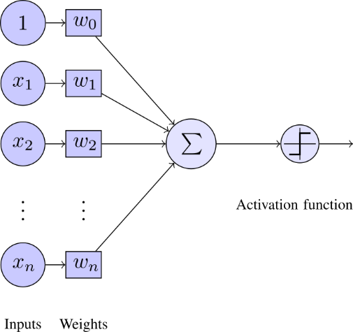

Figure 9: Perceptron Overview

As can be seen in **Figure 9**, a perceptron takes many weighted inputs, adds them together and passes the total to an activation function. The activation function then outputs a useful value depending on the sum of weighted inputs passed to it. In **Figure 9** the activation function is a step function, that is it will output 1 if the sum of the weighted inputs exceeds some threshold, and 0 otherwise. An analogy to biological neurons here would be that the perceptron will fire if the threshold is met.

**Figure 9** shows one perceptron, but an ANN is made up of many neurons or perceptrons. **Figure 10** shows a typical ANN, where there is an input layer, a hidden layer, and finally the output layer. In this example there is one hidden layer, but there can often be two or more hidden layers. Similarly there is not a restriction to one output for an ANN, there may be more than one perceptron in the output layer of the ANN. In the example, all information paths flow from the Input layer to the Output layer, which makes the network a feed forward network. There are other types of neural network which allow information to flow back in the opposite direction as well, these are known as feedback networks. Once there are more than two layers in the network (i.e. at least one hidden layer) the network is known as a multilayer perceptron network. Through the use of a training period, the correct weights may be assigned to the neurons in a network to accurately predict the outputs of a compressor system for a range of inputs.

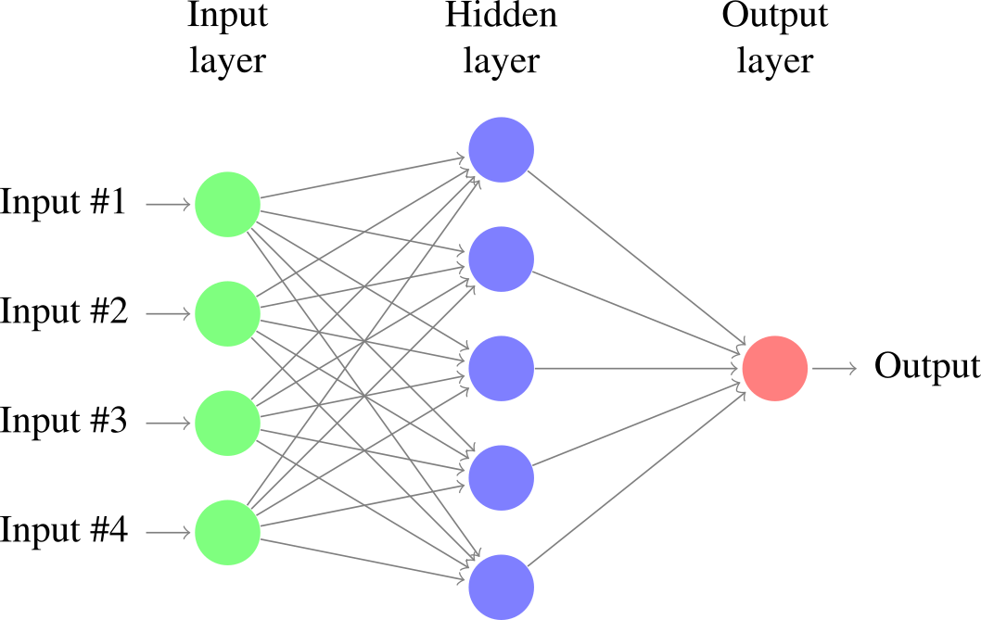

Figure 10: Typical Artifical Neural Network (ANN)

### Case Study: Regression Model Based Optimisation of a Network of Parallel Compressors

(Xenos et al. 2015) presented a paper describing a model-based optimisation of a network of air compressors in parallel. The compressors analysed were large (tens of MW) multistage centrifugal air compressors. The modelling approach taken was data-driven, in that training data was used to develop a black-box model of the air compressors.

Training data was split into a calibration step and a validation step, and a regression approach taken to determine the parameters of the model.

The values measured for input to the model were:

* ma = mass flow of air entering the compressor
* Tin = ambient temperature at compressor inlet
* pin = ambient pressure at compressor inlet
* pout = compressor discharge pressure

By taking these variables as inputs to the black-box model, the electrical power drawn by the compressor, Pel was determined for the different compressors in the compressor station.

The black-box model developed took the form of a polynomial regression model, given in

Where y*(i,t) = y(i,t) / ymaxi ; x(i,j,t) = x*(i,j,t) / xmax(i,j) are the scaled variables of the regression models of the compressors in set I, and y(i,t) = Pel(i,t). The parameters bm, m = 1,….,12 are calculated using regression methods.

In a related work (Xenos et al. 2014) the same authors developed two black box models with similar variables and the addition of the inlet guide vane angle as an input to the models. This allowed the mass flow rate of air to be predicted initially, with this predicted variable used together with the inlet guide vane angle, ambient temperature and pressure, and compressor discharge pressure to calculate the electrical power consumed by the compressor. The two approaches taken by the authors in these papers are summarised in **Figure 7** and **Figure 8.**

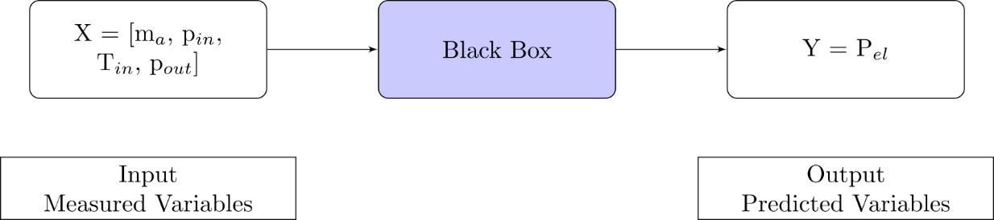

Figure : Black-box model for Power prediction (Xenos et al. 2015)

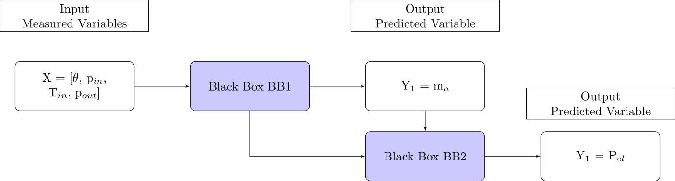

Figure : Alternative black-box model for Power prediction (Xenos et al. 2014)

By obtaining a mathematical model for the power drawn by the compressors in the compressor station (which are configured in parallel), the authors then attempted to optimise the plant’s operation in terms of electrical power drawn.

This was achieved by minimising the power of all compressors in the station according to the following equation:

This equation was subject to the following constraints, normalisations, mass balances and regression domain:

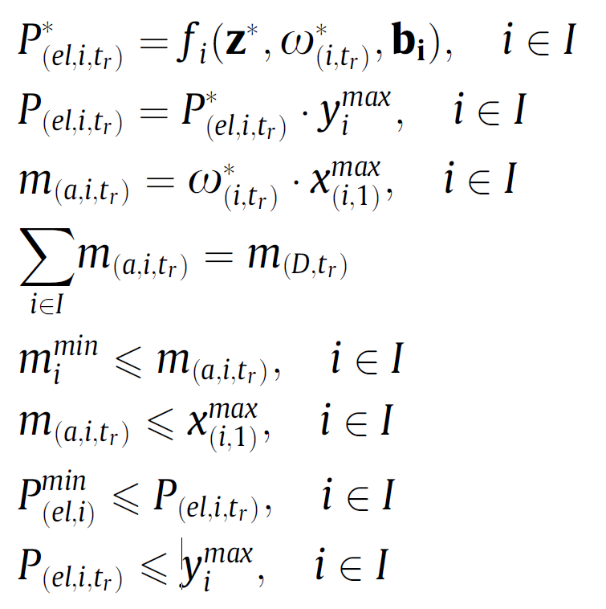

The optimisation approach was carried out by the authors in Matlab. The approach was successful in reducing the overall power consumption of the compressor station by optimally sharing the load between compressors. The optimisation approach resulted in a lower power consumption than the actual operation of the compressors, which shared the load using defined operational procedure for the test site.

### Compressor Performance Characteristic Map Generation Using Neural Networks

(Ghorbanian & Gholamrezaei 2009) presented a paper where different neural network model types were reviewed for accuracy in generating a gas generator’s compressor performance characteristic map. The four types reviewed were:

1. Generalised regression neural net-work (GRNN)
   * Generalised regression neural networks do not require an iterative training procedure, but rather approximate the functions between inputs from one initial training data set.
2. Modified GRNN
   * This method which was developed by the authors involved taking a GRNN and transforming the values to reduce the computational load involved in the initial training period
3. Multilayer perceptron network
   * In this paper the multilayer perceptron network involved two hidden layers, which could generate the compressor performance characteristic map when given the corrected massflow rate and rotational speed of the compressor in question.
4. Radial basis function network
   * This type of network uses radial basis functions as activation functions for each perceptron. The output of a radial basis function is dependent on the inputs distance from some origin, that is to say . This ensures that the output of the activation function is symmetrical about a mean which assists in reducing computational time for a neural network.

The two types of neural network found to be most effective in reconstructing a compressor’s performance map were modified or rotated GRNN and multilayer perceptron. Rotated GRNN was found to be most accurate in terms of closest agreement of results with training data, it was limited as a method to predicting the compressor performance map within the limits of training data given to it, and i.e. it is limited to interpolation. Multilayer perceptron networks are more suited to predicting a compressor’s performance characteristic at any operational point of the compressor, i.e. it can extrapolate to outside the given experimental training data. It was determined that multilayer perceptron neural networks are the most powerful of those reviewed in reconstructing compressor performance characteristic maps.

A key accuracy measure was that the performance map of a compressor was able to be reconstructed to 92% accuracy using 50% of available training data. Also by using the output of one neural network together with one measured parameter (corrected mass flow rate of air) as the inputs of another neural network the efficiency of the compressor could be predicted to an extremely high accuracy.

The authors had the same opinion as (Yu et al. 2007) in that neural networks provide an effective means of reconstructing a compressor’s characteristic performance curve when experimental or manufacturer’s data is not available, e.g. in off-design conditions.

# Discussion and Conclusion

This review took into consideration many different options for compressor performance management methods, each of which has its own merits and disadvantages. After consideration of each methods individual attributes, it appears that the most promising current research into compressor performance management lies between the qualitative model based and process history based methods. In particular, the data-driven regression model approach taken by (Xenos et al. 2015) and the ANN approach taken by (Ghorbanian & Gholamrezaei 2009) stand out as the state of the art for compressor optimisation and fault diagnosis. Clustering appears to have potential for categorisation of a compressor’s operating point. It is the intention of the author to explore these methods with a test data set from an operational compressed air station serving a small-scale pharmaceutical facility.

# Abbreviations

|  |  |
| --- | --- |
| Abbreviation | Meaning |
| AHP | Analytical Hierarchy Process |
| RCM | Reliability Centred Maintenance |
| FMEA | Failure Mode and Effect Analysis |
| FMECA | Failure Mode Effect and Criticality Analysis |
| FDD | Fault Detection and Diagnosis |
| RBM | Restricted Boltzmann Machine |
| WSM | Weighted Sum Model |
| ANN | Artificial Neural Network |
| MLP | Multi Layer Perceptron |

# References

Backi, C.J., Gravdahl, J.T. & Grøtli, E.I., 2013. Nonlinear observer design for a Greitzer compressor model. , pp.1457–1463.

Bevilacqua, M. & Braglia, M., 2000. The analytic hierarchy process applied to maintenance strategy selection. *Reliability Engineering & System Safety*, 70(1), pp.71–83.

Blesa, J. et al., 2014. An Interval NLPV Parity Equations Approach for Fault Detection and Isolation of a Wind Farm. *IEEE Transactions on Industrial Electronics*, 0046(c), pp.1–1. Available at: http://ieeexplore.ieee.org/articleDetails.jsp?arnumber=6998858.

Catterson, V. & Costello, J., 2013. Increasing the Adoption of Prognostic Systems for Health Management in the Power Industry. *Chemical Engineering Transactions*, 33, pp.271–276. Available at: http://www.aidic.it/cet/13/33/046.pdf.

Cortés, O., Urquiza, G. & Hernández, J. a., 2009. Optimization of operating conditions for compressor performance by means of neural network inverse. *Applied Energy*, 86(11), pp.2487–2493. Available at: http://dx.doi.org/10.1016/j.apenergy.2009.03.001.

Cui, H. et al., 2009. Research on fault diagnosis for reciprocating compressor valve using information entropy and SVM method. *Journal of Loss Prevention in the Process Industries*, 22(6), pp.864–867. Available at: http://dx.doi.org/10.1016/j.jlp.2009.08.012.

Dapeng Niu et al., 2011. Modelling of multistage centrifugal compressor. In *Proceedings of 2011 International Conference on Computer Science and Network Technology*. IEEE, pp. 1144–1147. Available at: http://ieeexplore.ieee.org/lpdocs/epic03/wrapper.htm?arnumber=6182163.

Dasilva, A.R., 2004. Controlling the radiation of hermetic compressors by means of minimization of power through discharge pipes using genetic algorithms_2004.pdf. In *International Compressor Engineering Conference*.

Demetgul, M., 2013. Fault diagnosis on production systems with support vector machine and decision trees algorithms. *The International Journal of Advanced Manufacturing Technology*, 67(9-12), pp.2183–2194. Available at: http://link.springer.com/10.1007/s00170-012-4639-5.

Facchinetti, T., Benetti, G. & Vedova, M.L. Della, Modeling and real-time control of an industrial air multi-compressor system.

Friden, H. et al., 2012. Energy and LCC Optimised Design of Compressed Air Systems: A Mixed Integer Optimisation Approach with General Applicability. *2012 UKSim 14th International Conference on Computer Modelling and Simulation*, (Lcc), pp.491–496. Available at: http://ieeexplore.ieee.org/lpdocs/epic03/wrapper.htm?arnumber=6205496.

Gao, Z., Cecati, C. & Ding, S.X., 2015a. A Survey of Fault Diagnosis and Fault-Tolerant Techniques Part I: Fault Diagnosis. *Industrial Electronics, IEEE Transactions on*, PP(99), p.1.

Gao, Z., Cecati, C. & Ding, S.X., 2015b. A Survey of Fault Diagnosis and Fault-Tolerant Techniques Part II: Fault Diagnosis with Knowledge-Based and Hybrid/Active Approaches. *Industrial Electronics, IEEE Transactions on*, PP(99), p.1.

Gertler, J., 1998. *Fault Detection and Diagnosis in Engineering Systems*, Available at: http://books.google.com/books?id=fmPyTbbqKFIC.

Ghorbanian, K. & Gholamrezaei, M., 2009. An artificial neural network approach to compressor performance prediction. *Applied Energy*, 86(7-8), pp.1210–1221. Available at: http://dx.doi.org/10.1016/j.apenergy.2008.06.006.

Glass, a S. et al., 1995. Qualitative model-based fault detection in air-handling units. *IEEE Control Systems Magazine*, 15(4), pp.11–22. Available at: http://www.scopus.com/inward/record.url?eid=2-s2.0-0029359274&partnerID=40&md5=190fc8710ebf04754f9055cc492f4691.

Van Harmelen, F., Lifschitz, V. & Porter, B., 2008. *Handbook of Knowledge Representation*, Elsevier Science. Available at: https://books.google.ie/books?id=xwBDylHhJhYC.

IEA, 2012. International Energy Agency. *IEA*. Available at: http://www.iea.org [Accessed August 5, 2015].

James Li, C. & Yu, X., 1995. High pressure air compressor valve fault diagnosis using feedforward neural networks. *Mechanical Systems and Signal Processing*, 9(5), pp.527–536. Available at: http://www.sciencedirect.com/science/article/pii/S0888327085700404 [Accessed July 23, 2015].

Jinru, L., Yibing, L. & Keguo, Y., 2008. Fault diagnosis of piston compressor based on Wavelet Neural Network and Genetic Algorithm. *2008 7th World Congress on Intelligent Control and Automation*, pp.6006–6010. Available at: http://ieeexplore.ieee.org/lpdocs/epic03/wrapper.htm?arnumber=4592852.

Kabbaj, N. et al., 2003. Fault detection and isolation in a greenhouse using parity relations. *EFTA 2003. 2003 IEEE Conference on Emerging Technologies and Factory Automation. Proceedings (Cat. No.03TH8696)*, 2(OCTOBER).

Katipamula, S. & Brambley, M., 2005. Review Article: Methods for Fault Detection, Diagnostics, and Prognostics for Building Systems—A Review, Part I. *HVAC&R Research*, 11(2), pp.169–187. Available at: http://www.tandfonline.com/doi/abs/10.1080/10789669.2005.10391133.

Kopanos, G.M. et al., 2015. Optimization of a network of compressors in parallel: Operational and maintenance planning – The air separation plant case. *Applied Energy*, 146, pp.453–470. Available at: http://linkinghub.elsevier.com/retrieve/pii/S0306261915001166.

Krichel, S. V & Sawodny, O., 2011. Analysis and optimization of compressed air networks with model-based approaches. *Pneumatica*, pp.334–341.

Lingling, H., 2010. Fault diagnosis model of the diesel locomotive air brake system based on Bayesian network. , pp.0–2.

Liu, C. et al., 2013. Large flow compressed air load forecasting based on Least Squares Support Vector Machine within the Bayesian evidence framework. *IECON Proceedings (Industrial Electronics Conference)*, (2011), pp.7886–7891.

Liu, J. & Chen, D.-S., 2009. Fault Detection and Identification Using Modified Bayesian Classification on PCA Subspace. *Industrial & Engineering Chemistry Research*, 48(6), pp.3059–3077. Available at: http://www.scopus.com/inward/record.url?eid=2-s2.0-65349135893&partnerID=tZOtx3y1.

Liu, S.-Y.S.-C., 2001. An Efficient Expert System for Air Compressor Troubleshooting. *Expert Systems*, 18(4), pp.203–214. Available at: http://doi.wiley.com/10.1111/1468-0394.00175 [Accessed April 10, 2014].

Luo Fangqiong & Huang Shengzhong, 2011. Research and Application of Wavelet Neural Network Based on the Optimization of Genetic Algorithm in Centrifugal Compressor’s Performance Prediction. *2011 Third International Conference on Measuring Technology and Mechatronics Automation*, 9, pp.1027–1030. Available at: http://ieeexplore.ieee.org/lpdocs/epic03/wrapper.htm?arnumber=5721364.

Mazid, A.M. & Martin, R., 2008. Automation of compressor test procedure using advantech data acquisition module. In *2008 10th International Conference on Control, Automation, Robotics and Vision*. IEEE, pp. 2266–2271. Available at: http://ieeexplore.ieee.org/lpdocs/epic03/wrapper.htm?arnumber=4795885.

Nair, A.T. et al., 2011. Kalman Filter Based State Estimation of a Thermal Power Plant. *2011 International Conference on Process Automation, Control and Computing*, pp.1–5. Available at: http://ieeexplore.ieee.org/xpls/abs_all.jsp?arnumber=5978971\nhttp://ieeexplore.ieee.org/lpdocs/epic03/wrapper.htm?arnumber=5978971.

Namdeo, R., Manepatil, S. & Saraswat, S., 2008. Detection of Valve Leakage in Reciprocating Compressor Using Artificial Neural Network ( Ann ). , pp.1–8.

Pathak, N., Khan, M. & Roy, N., 2015. Acoustic based appliance state identifications for fine-grained energy analytics. *IEEE International Conference on Pervasive Computing and Communications (PerCom)*, pp.63–70. Available at: http://ieeexplore.ieee.org/xpls/abs_all.jsp?arnumber=7146510.

Petković, M. et al., 2012. On-line adaptive clustering for process monitoring and fault detection. *Expert Systems with Applications*, 39(11), pp.10226–10235.

Qin, Q. et al., 2012. A novel scheme for fault detection of reciprocating compressor valves based on basis pursuit, wave matching and support vector machine. *Measurement: Journal of the International Measurement Confederation*, 45(5), pp.897–908. Available at: http://dx.doi.org/10.1016/j.measurement.2012.02.005.

Radgen, P., 2006. Efficiency through compressed air energy audits. In *Energy Audit Conference, www. audit06. fi*.

Ramezanifar, a, Afshar, a & Nikravesh, S.K.Y., 2006. State Estimation of a Boiler Using Nonlinear Observer. *Information and Control*.

Ren, Y. et al., 2012. Reliability Assessment of Anti-surge Control System in Centrifugal Compressor. *2012 Fourth International Conference on Computational and Information Sciences*, pp.1240–1243. Available at: http://ieeexplore.ieee.org/lpdocs/epic03/wrapper.htm?arnumber=6301343.

Ruilin Lin, Boyun Liu & Qi Liu, 2010. Study of the non-liner dynamic system theory for reciprocating compressor fault diagnosis. In *2010 International Conference on Computer Application and System Modeling (ICCASM 2010)*. IEEE, pp. V9–245–V9–248. Available at: http://ieeexplore.ieee.org/lpdocs/epic03/wrapper.htm?arnumber=5623041.

Saaty, T.L., 2008. Decision making with the analytic hierarchy process. *International Journal of Services Sciences*, 1(1), p.83.

Saidur, R., Rahim, N.A. & Hasanuzzaman, M., 2010. A review on compressed-air energy use and energy savings. *Renewable and Sustainable Energy Reviews*, 14(4), pp.1135–1153. Available at: http://www.sciencedirect.com/science/article/pii/S1364032109002755 [Accessed March 24, 2014].

Salar, A. et al., 2010. Improving Model-Based Gas Turbine Fault Diagnosis Using Multi-Operating Point Method. *2010 Fourth UKSim European Symposium on Computer Modeling and Simulation*, (2), pp.240–247. Available at: http://ieeexplore.ieee.org/lpdocs/epic03/wrapper.htm?arnumber=5703690.

SEAI, 2007. *Compressed Air Technical Guide*, Dublin.

Shin, B. et al., 2007. Application of fault diagnosis based on signed digraphs and PCA with linear fault boundary. *2007 International Conference on Control, Automation and Systems*, pp.984–987. Available at: http://ieeexplore.ieee.org/lpdocs/epic03/wrapper.htm?arnumber=4407067.

Tarantino, R., Szigeti, F. & Colina-Morles, E., 2000. Generalized Luenberger observer-based fault-detection filter design: An industrial application. *Control Engineering Practice*, 8(6), pp.665–671.

Tran, V.T., Althobiani, F. & Ball, A., 2014. An approach to fault diagnosis of reciprocating compressor valves using Teager-Kaiser energy operator and deep belief networks. *Expert Systems with Applications*, 41(9), pp.4113–4122. Available at: http://dx.doi.org/10.1016/j.eswa.2013.12.026.

Vachtsevanos, G. et al., 2006. *Intelligent Fault Diagnosis and Prognosis for Engineering Systems*, Hoboken, NJ, USA: John Wiley & Sons, Inc. Available at: http://doi.wiley.com/10.1002/9780470117842.

Venkatasubramanian, V., Rengaswamy, R., Yin, K., et al., 2003. A review of process fault detection and diagnosis. *Computers & Chemical Engineering*, 27(3), pp.293–311. Available at: http://linkinghub.elsevier.com/retrieve/pii/S0098135402001606.

Venkatasubramanian, V., 2003. A review of process fault detection and diagnosis: Part III: Process history based methods. *Computers & chemical …*, 27, pp.293–311. Available at: http://www.sciencedirect.com/science/article/pii/S009813540200162X.

Venkatasubramanian, V., Rengaswamy, R. & Kavuri, S.N., 2003. A review of process fault detection and diagnosis: Part II: Qualitative models and search strategies. *Computers & Chemical Engineering*, 27(3), pp.313–326. Available at: http://www.sciencedirect.com/science/article/pii/S0098135402001618\nhttp://www.sciencedirect.com/science/article/pii/S0098135402001618/pdfft?md5=09aaf3029aa870816812fdf60c453e47&pid=1-s2.0-S0098135402001618-main.pdf.

Verma, N.K., Roy, A. & Salour, A., 2011. An optimized fault diagnosis method for reciprocating air compressors based on SVM. *Proceedings - 2011 IEEE International Conference on System Engineering and Technology, ICSET 2011*, pp.65–69.

Wang, F. et al., 2010. Fault Diagnosis for Reciprocating Air Compressor Valve Using P-V Indicator Diagram and SVM. *2010 Third International Symposium on Information Science and Engineering*, (109047), pp.255–258. Available at: http://ieeexplore.ieee.org/lpdocs/epic03/wrapper.htm?arnumber=5945097.

Wang, S. & Cui, J., 2005. Sensor-fault detection, diagnosis and estimation for centrifugal chiller systems using principal-component analysis method. *Applied Energy*, 82(3), pp.197–213. Available at: http://linkinghub.elsevier.com/retrieve/pii/S0306261904001953.

Wheeler, T.J. et al., 2011. Performance analysis of fault detection systems based on analytically redundant linear time-invariant dynamics. *Proceedings of the American Control Conference*, pp.214–219. Available at: http://www.scopus.com/inward/record.url?eid=2-s2.0-80053146995&partnerID=tZOtx3y1.

Xenos, D.P. et al., 2015. Optimization of a network of compressors in parallel: Real Time Optimization (RTO) of compressors in chemical plants – An industrial case study. *Applied Energy*, 144, pp.51–63. Available at: http://linkinghub.elsevier.com/retrieve/pii/S0306261915000161.

Xenos, D.P. et al., 2014. Preprocessing of Raw Data for Developing Steady-State Data-Driven Models for Optimizing Compressor Stations. , (July).

Xiaogang, W., Xueliang, B. & Bo, J., 2013. Adaptive genetic algorithm for parameter identification of centrifugal compressor. *2013 25th Chinese Control and Decision Conference (CCDC)*, pp.2982–2986. Available at: http://ieeexplore.ieee.org/lpdocs/epic03/wrapper.htm?arnumber=6561456.

Yu, Y. et al., 2007. Neural-network based analysis and prediction of a compressor’s characteristic performance map. *Applied Energy*, 84(1), pp.48–55.

Zanoli, S.M. & Astolfi, G., 2013. Application of a Fault Detection and Isolation System on a Rotary Machine. *International Journal of Rotating Machinery*, 2013, pp.1–11. Available at: http://www.hindawi.com/journals/ijrm/2013/189359/.

Zanoli, S.M., Astolfi, G. & Barboni, L., 2010a. Applications of fault diagnosis techniques for a multishaft centrifugal compressor. *18th Mediterranean Conference on Control and Automation, MED’10 - Conference Proceedings*, pp.64–69.

Zanoli, S.M., Astolfi, G. & Barboni, L., 2010b. FDI of process faults based on PCA and cluster analysis. *2010 Conference on Control and Fault-Tolerant Systems (SysTol)*, pp.197–202. Available at: http://ieeexplore.ieee.org/lpdocs/epic03/wrapper.htm?arnumber=5676023.

Zhu, X. et al., 2013. A quantitative comprehensive safety evaluation method for centrifugal compressors using FMEA-fuzzy operations. In *2013 2nd International Symposium on Instrumentation and Measurement, Sensor Network and Automation (IMSNA)*. IEEE, pp. 202–206. Available at: http://ieeexplore.ieee.org/lpdocs/epic03/wrapper.htm?arnumber=6743251.

|  |  |  |  |  |  |
| --- | --- | --- | --- | --- | --- |
| ***Group*** | ***Examples*** | ***Description*** | ***Capabilities*** | ***Pros*** | ***Cons*** |
| Group 1: Knowledge Based Methods | Limit checking | Applying thresholds to key sensor values to alert site personnel when alarm level is reached | Failure Analysis Maintenance Planning Decision Support | Significant amount of human knowledge may be formally recorded | Large time commitment required for each and every implementation Difficult to transfer lessons learned to new applications |
| Physical redundancy | Installing parallel sensors in order that site personnel be notified of an error if sensor values do not match |
| Spectrum analysis | Analysis of compressor drive frequency response to alert when response drifts from normal |
| FMEA / FMECA | Analysis of site equipment to determine potential areas of failure and potential effect on other equipment |
| Fault Tree Analysis | Postulation of all potential areas of failure in equipment |
| AHP | Analysis of criticality of equipment to best allocate maintenance resources |

Table : Group 1 Compressor Performance Management Methods

|  |  |  |  |  |  |
| --- | --- | --- | --- | --- | --- |
| ***Group*** | ***Examples*** | ***Description*** | ***Capabilities*** | ***Pros*** | ***Cons*** |
| Group 2: Real-time performance management methods Deterministic | Kalman Filter | A Kalman filter may be created for each defined fault state in order to predict the outputs of the compressed air system, and if the prediction error of any filter is zero the system can be diagnosed as being in the relevant fault state | FDD Optimisation Performance comparison and analysis | Typically give a high level of confidence in prediction of plant variables, allowing informed decision making concerning performance improvement opportunities | Normally require a high level of modelling capability from site engineers which may be outside normal role responsibilities New modelling typically required for each performance management implementation |
| Diagnostic Observers | Using observers to form hypothesises as to how to change a model to remove deviations from expected behaviour in order to diagnose potential faults |
| Parity Relations | Manipulating system variables to generate fault signatures in the form of residual differences which can be used in operation to diagnose faults |
| Parameter Estimation | Creating a reference fault-free model of a system and analysing actual deviations in variables to diagnose faults, or tuning model in order to optimise the system with respect to some defined factor (e.g. cost) |
| Engineering rules | Formalising potential faults through the use of IF statements to determine when a system is in fault condition by virtue of fundamental engineering principles being broken or changed |

Table : Group 2 Compressor Performance Management Methods

|  |  |  |  |  |  |
| --- | --- | --- | --- | --- | --- |
| ***Group*** | ***Examples*** | ***Description*** | ***Capabilities*** | ***Pros*** | ***Cons*** |
| Group 3: Predictive performance management methods Stochastic / Probabilistic Data Mining Statistical Learning Machine Learning | Artificial neural networks | Creation of a network of elements or neurons which may determine variable values based on interconnected element's response to external inputs | FDD Predictive Maintenance Optimisation Analytics Automated Commissioning Automatic Performance Comparison and Analysis | Typically require minimal input from engineering experts Concepts are typically understandable to site engineering when input is required Lessons learned in one facility may be readily applied to new applications given relatively similar configurations of equipment | Typically require a learning period in fault-free condition Probabilistic method involves a level of risk - prediction results may not be as accurate as deterministic, engineering-based methods |
| Association rule learning | Identification of interesting relationships between variables by recognising statistically significant historical relationships |
| Bayesian networks | Creation by learning or using prior knowledge of graphical probabilistic models which give relationships between variables |
| Clustering | Grouping data readings into different groups where intragroup similarity is greater than intergroup similarity |
| Decision tree learning | Definition of the condition a system may be in based on observed variables, represented graphically using a tree structure which may be generated from past data using algorithms such as the ID3 algorithm |
| Genetic algorithms | Determining the optimum point a system can operate at, by selecting random members of a population of samples and using them as parents of successive samples, which tend toward the optimal sample |
| Reinforcement learning | As distinct from supervised and unsupervised learning techniques, this method requires feedback on whether it has correctly predicted the value of a variable and tends toward an optimum based on this feedback |
| PCA | Analysis of a population of variables to determine the population extremes in a given number of directions or components, allowing categorisation of each data point in terms of its position in each direction |
| Support vector machines | A supervised learning technique which when given a sample data set which is labelled according to which class each point belongs in, can determine the optimal plane which splits classes allowing accurate future classification of variables |

Table : Group 3 Performance Management Methods

## Knowledge Based Methods

Knowledge based methods are defined for the purposes of this review as those methods which attempt to formalise in code or otherwise the reasoning of a human expert. These systems represent an approach where the engineering or equipment knowledge of an expert is applied in a heuristic fashion.

These systems typically require heavy engagement from system and equipment experts at the time of deployment. This engagement may take the form of interviews and/or site visits with key personnel. The individual opinions of site personnel may vary from facility to facility, and this may prevent lessons learnt being transferred across industries.

From this review it appears that these methods are useful to a certain extent and may be deployed in a facility to ensure that if key personnel retire, valuable knowledge about a compressed air system is not lost. However the amount of time and engagement required for deployment would suggest that for rapid performance improvements in compressed air system performance, other approaches would be more suitable.

## Model-Based Methods

The second category of method for compressor performance management considered in this review are model based methods. These methods are deterministic in that they employ some model which will always generate the same output for given inputs.

Model-based methods for compressor performance management may be broadly divided into two categories:

1. Analytical redundancy methods
2. Parameter estimation methods

Both of these approaches rely on generating residual patterns for diagnosis of why a compressor is not performing as expected, i.e. fault detection and diagnosis. Parameter estimation methods may be used for compressor optimisation and performance analysis.

Analytical redundancy methods are further subdivided into the following categories:

1. Kalman Filters
2. Diagnostic Observers
3. Parity (Consistency) Relations

For the purpose of fault detection and diagnosis, the difference between model-based methods and other traditional methods such as those discussed in **Section 4.1** is evident in the concept of redundancy. Where model-free methods often employ physical redundancy by comparing identical sensors in parallel to determine faults, model-based methods usually incorporate some level of analytical redundancy (Gertler 1998). This analytical redundancy compares actual sensor readings with analytically calculated values to determine when a system is in fault condition. Any differences between calculated and measured values may then be represented as residuals. These residuals may then be evaluated to diagnose the specific fault in the compressed air system. Often the analytically calculated values are generated for a variety of fault conditions, to determine the residual patterns for each fault. This process is summarised in **Figure 11.**



Figure : Typical Model-Based FDD Process

The analytical redundancy approaches to fault detection are summarised as follows:

1. Kalman Filters
   * A Kalman Filter can remove noise to assist in the prediction of a variable from a mathematical model. Since the prediction error of the Kalman filter will be zero in the case of no fault, the residual generated may be used as a fault detection residual. In addition, Kalman filters may be constructed for each potential fault state of a compressed air system, and if the prediction error of the filter is zero for any of the bank of filters, the fault in question may be diagnosed. Kalman filters have been used with some success to detect compressed air leakage by (Krichel & Sawodny 2011).
2. Diagnostic Observers
   * Diagnostic observers can be used to diagnose faults by analysing a deviation from expected behaviour, and forming a diagnostic hypothesis as a change to the mathematical model of the compressed air system which removes the deviation from expected behaviour (van Harmelen et al. 2008).
3. Parity (consistency) relations
   * Parity relations are a method for fault diagnosis which operate by manipulating compressed air model observables in order to generate the residuals associated with particular faults (Kabbaj et al. 2003). These residuals may then be compared with measured residuals for fault diagnosis.

Parameter estimation operates differently to analytical redundancy methods in that a reference model is first created by identifying a fault-free condition of the compressed air plant (Gertler 1998). Deviations from this reference model are then used to generate residuals, which must be individually evaluated to diagnose faults. This method is reliable in that the intervention of a human expert is typically required at the residual evaluation stage, however this adds a time cost to the method.

For the purpose of optimisation model-based methods can be used to improve a compressed air system’s performance with respect to some variable (e.g. energy efficiency). This can be achieved by analysing many potential operational scenarios through a computer model, with no risk to an installed system, before implementing a change to the physical plant’s operational characteristics. This is the method and goal which are reviewed in **Section** Error! Reference source not found.of this paper.

## Probabilistic Methods

The final category of method for compressor performance management considered in this review is the category of probabilistic or stochastic methods. This category encompasses approaches including data mining, statistical learning and machine learning.

With these methods there is an element of probability, for example for a fault diagnosis application, there is typically a goal of identifying faults to some degree of accuracy.

Probabilistic methods have been applied in various forms to compressor performance management. Artificial Neural Networks (ANNs) have been applied for the purpose of generating a compressor’s performance map when a degradation in performance has occurred (Yu et al. 2007; Ghorbanian & Gholamrezaei 2009) and to optimise a compressor’s operating conditions (Cortés et al. 2009). ANNs, Support Vector Machines (SVMs) and Deep Belief Networks (DBNs) have both been used with success to detect valve faults in reciprocating air compressors (Cui et al. 2009; Qin et al. 2012; Verma et al. 2011; James Li & Yu 1995; Tran et al. 2014). Fault diagnosis of sensors and actuators in centrifugal compressor equipment using Principal Component Analysis (PCA) has been achieved (Zanoli et al. 2010a). (Petković et al. 2012) presented a clustering method for fault detection of air compressors.

From this review an ANN based approach appears to be the most prolific method of compressor performance management in recent literature, therefore ANNs will be discussed and an example paper which applied an ANN approach will be reviewed.